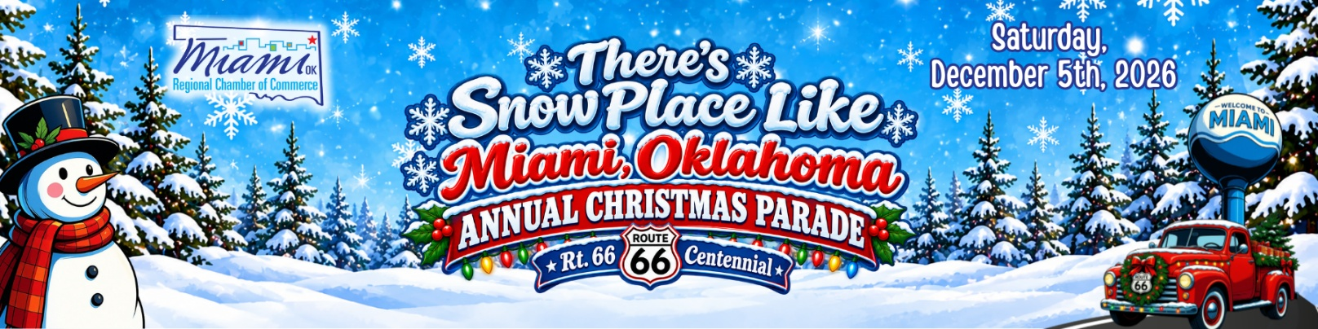
🎄

MIAMI CHRISTMAS PARADE 2026
"There's Snow Place Like Miami, Oklahoma"
Celebrating the Route 66 Centennial
Saturday, December 5, 2026 | 6:00 PM | Downtown Miami, Oklahoma

Guidelines & Information
Please read these guidelines carefully and share them with everyone participating in your parade entry. Registration in the parade constitutes agreement to follow all parade rules and instructions.

REGISTRATION REQUIREMENTS

Registration is a Two-Step Process
Your parade entry is not considered complete until:
✅ The online Parade Registration Form has been submitted.
✅ Payment has been received through the Miami Regional Chamber of Commerce portal.
Incomplete registrations may not be assigned a parade position.

Judging Category Selection
Participants wishing to be judged must select one award category during registration.
Each entry may only compete in one award category.

2026 THEME
❄️ "There's Snow Place Like Miami, Oklahoma"
Celebrating the Route 66 Centennial
This year's theme combines the warmth of a hometown Christmas celebration with the historic Route 66 Centennial. Participants are encouraged to creatively incorporate winter, holiday, snow-themed, and Route 66-inspired elements into their entries.
Ideas may include:
- Snow-covered Route 66 landmarks
- Winter wonderlands along the Mother Road
- Vintage vehicles decorated for the holidays
- Route 66 diners, gas stations, and attractions
- Holiday travel and road trip themes
- Santa cruising Historic Route 66
- Festive lights and holiday music
All entries must demonstrate reasonable effort to incorporate holiday decorations and/or this year's theme. Undecorated vehicles may be moved to the end of the parade or disqualified from award consideration.
All entries are strongly encouraged to include lights since the parade is at night.

PARADE ROUTE
The parade will begin at 5th Street and Main Street and travel south through Downtown Miami.
The parade will disperse at 2nd Street and Main Street. All entries will turn east at 2nd Street and continue to designated exit routes to prevent traffic congestion.
Additional unloading and parking instructions for large groups, bands, and teams will be provided before the event.

LINEUP INFORMATION
Check-In Location
All entries must check in before entering the lineup area.
Participants should enter the staging area from the designated check-in point and obtain their parade entry number from parade volunteers.

Important Reminders
- All parade participants must be checked in before entering the lineup area.
- Only registered parade vehicles and entries will be permitted in the staging area.
- Individuals should be dropped off before entering the lineup area.
- If your entry consists of multiple vehicles or units, all participants must arrive together for lineup.
- Parade participants should be in place and ready before lineup deadlines provided by event organizers.
- Detailed lineup instructions and maps will be emailed to registered participants before the parade.

ANNOUNCER INTRODUCTION
Each registered entry must provide an announcer introduction during registration.
This script will be read during the parade and may be included in livestreams, recordings, and social media coverage.

Recommended Length
- 75 to 150 words
- Approximately 30 to 60 seconds when read aloud
Please provide the announcement exactly as you would like it read.
The Chamber reserves the right to edit submissions for length, clarity, or appropriateness.

PARADE REQUIREMENTS

Entry Numbers
Each entry will receive a parade number at check-in. This number must remain visible throughout the parade so judges and announcers can identify your entry.

Santa Claus Policy
To preserve the excitement of the parade finale, we ask that parade participants not include a live Santa Claus in their entry.
Stuffed, decorative, inflatable, or imitation Santas are welcome.
The official Miami Christmas Parade Santa will appear at the conclusion of the parade.

Candy Distribution
For the safety of parade attendees:
❌ Do not throw candy or other items from moving vehicles.
✅ Participants may walk alongside their entry and hand items directly to spectators.

Spacing
Please maintain a safe and consistent distance between your entry and the unit ahead of you to allow judges and announcers sufficient time to recognize each participant.

2026 PARADE AWARDS
Participants may select one award category during registration.

Holiday Spirit Award
Awarded to the entry displaying the best overall creativity, appearance, and originality.

Elfin Magic Award
Best entry featuring children.

Tin Soldier Award
Best pedestrian or walking entry.

Santa's Choice Award
Best float entry.

Santa's Sleigh Award
Best vehicle entry.

Rudolph's Award
Best animal entry.

Silver Bells Award
Best band performance.

LIABILITY & CONDUCT
By participating in the parade, entrants agree to:
- Follow all parade instructions and safety requirements.
- Operate vehicles in a safe and responsible manner.
- Supervise all participants associated with their entry.
- Hold harmless the Miami Regional Chamber of Commerce, its staff, volunteers, board members, sponsors, partners, and the City of Miami from any claims, injuries, damages, or losses arising from participation in the event.
The Miami Regional Chamber of Commerce reserves the right to refuse or remove any entry that does not comply with parade rules or standards.

QUESTIONS?
Miami Regional Chamber of Commerce 11 S. Main Street Miami, OK 74354
📞 918-542-4481
📧 Office@miamiokchamber.com

